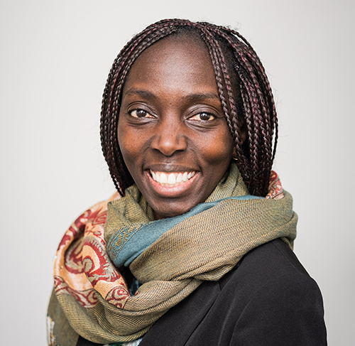
Speaker Bio
Louise Adongo, Executive Director
Inspiring Communities
Louise Adongo is a bold and grounded leader who brings over a decade of experience in systems change, policy and evaluation to Inspiring Communities. She is known for bringing care and intention to uncovering the roots of tangled problems; and enabling shifts to greater resilience, sustainability and impact.
She believes in carving institutional spaces that are more nimble, transparent and creative. For the last decade she has worked for the Nova Scotia government’s departments of Health, Justice (NSHRC), Labour & Advanced Education, Business (ERDT), Service Nova Scotia & Internal Services and Infrastructure & Housing. There, Louise advanced work on social labs in government, convened Policy Circles to encourage connection & communication among policy professionals on timely topics and initiated interdepartmental collaborations to support wellness and career advancement of Black women. She co-Chaired the African-Canadian Women in the Public Service Network (ACWPS).
Unafraid of challenge or change, Louise has a deep commitment to advancing social justice and anti-racism. She has guided the Avalon Sexual Assault Centre’s reorganization as their interim Board Chair, co-led a Black Women and Leadership Forum and facilitated organizational & strategic planning sessions for a variety of community organizations. She sits on the Board of Directors of the CUA and previously volunteered with the Health Association of African Canadians (HAAC ), the Halifax Local Immigrant Partnership (HLIP ), and as co-founder & Board Secretary for the Freetown Initiative (now Help2Overcome). She was also the co-chair of the 2019 Canadian Evaluation Society National Conference.
Louise is able to seamlessly navigate among the cultures of community, non-profit, business and government to make incredible things happen. She holds graduate degrees in Applied Health Services Research and Plant Biochemistry.
She is a proud mother of a young toddler and is often creatively fired up about a wide range of subjects. To relax, she gardens, reads, explores new places in the Atlantic region and enjoys talks about system change on patios or in living rooms with friends.

